* 1. 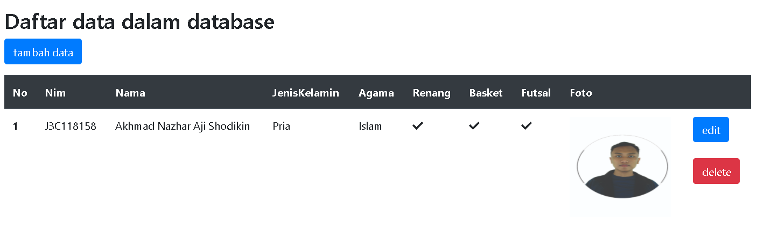Menampilkan Data
  2. 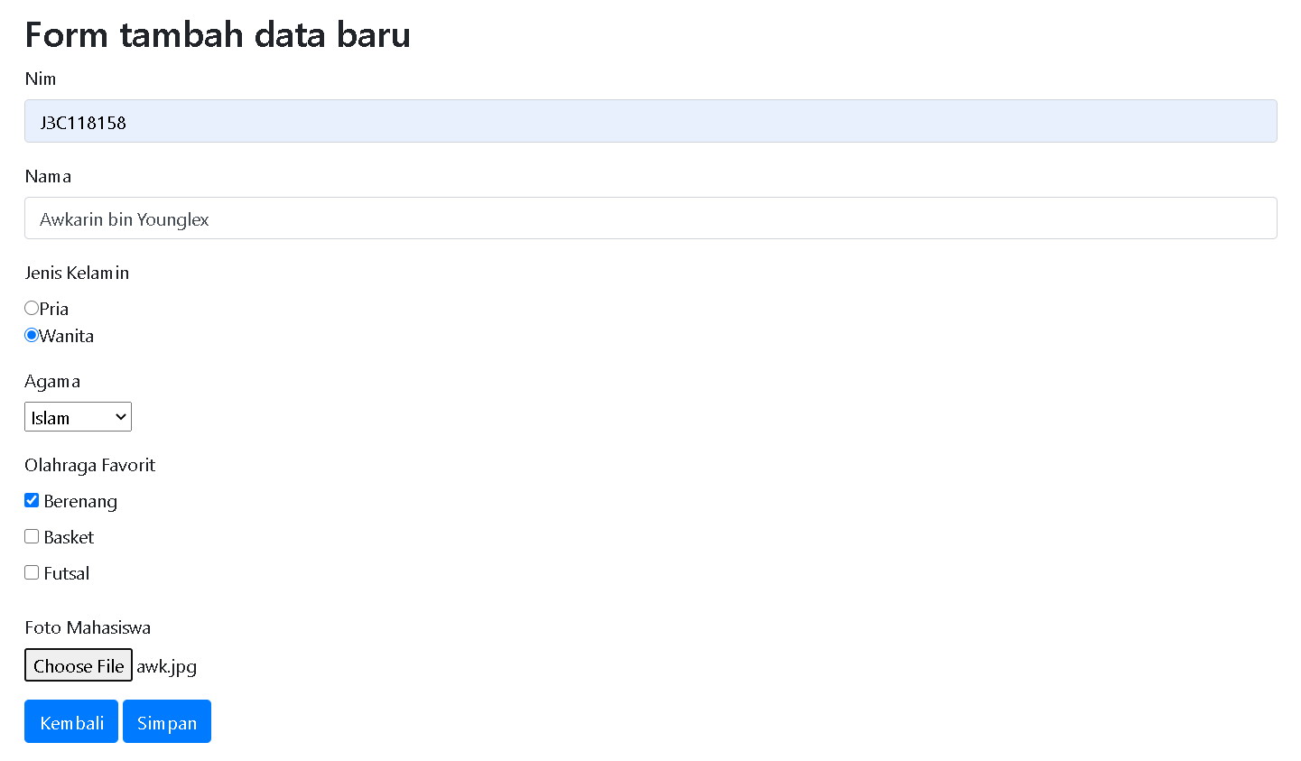Menambahkan Data



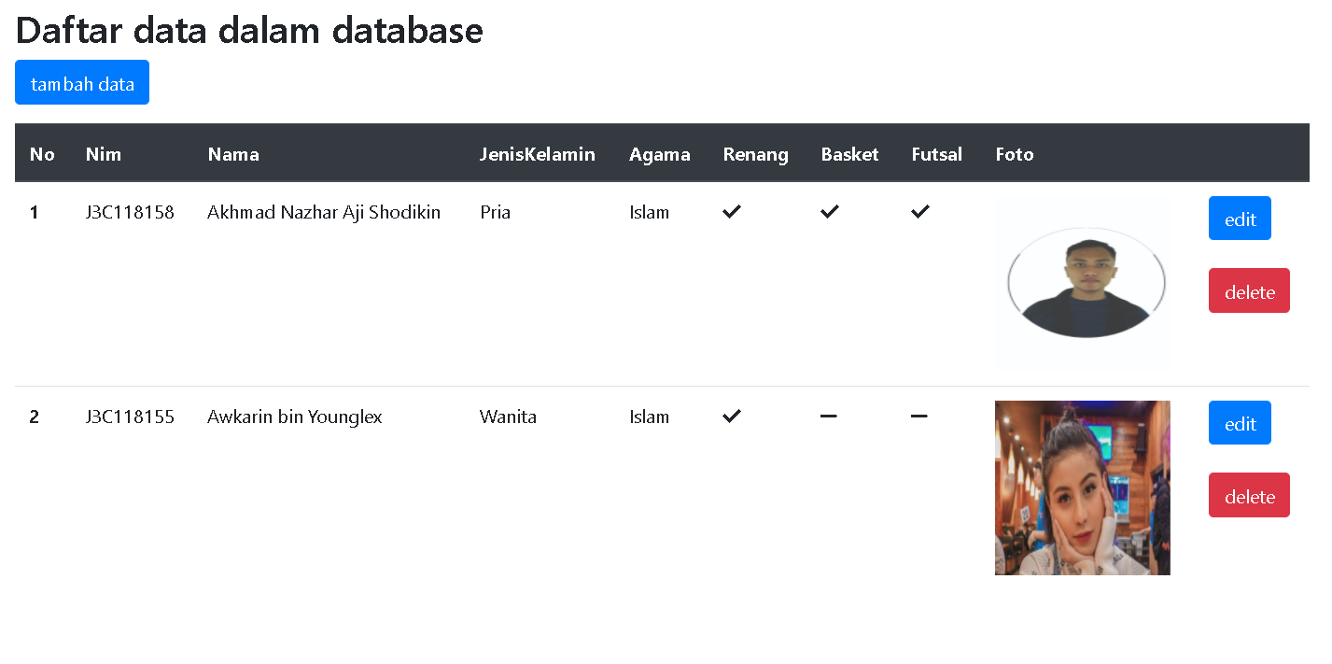

* 1. 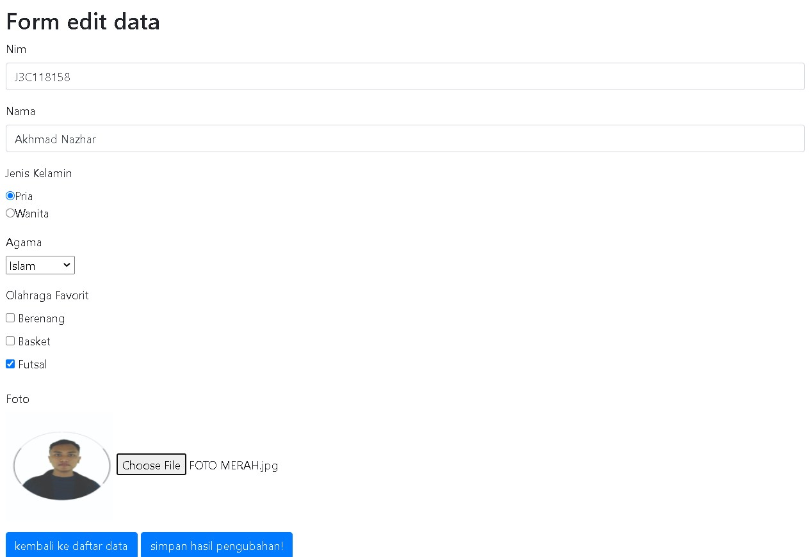Mengedit Data

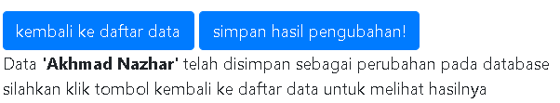

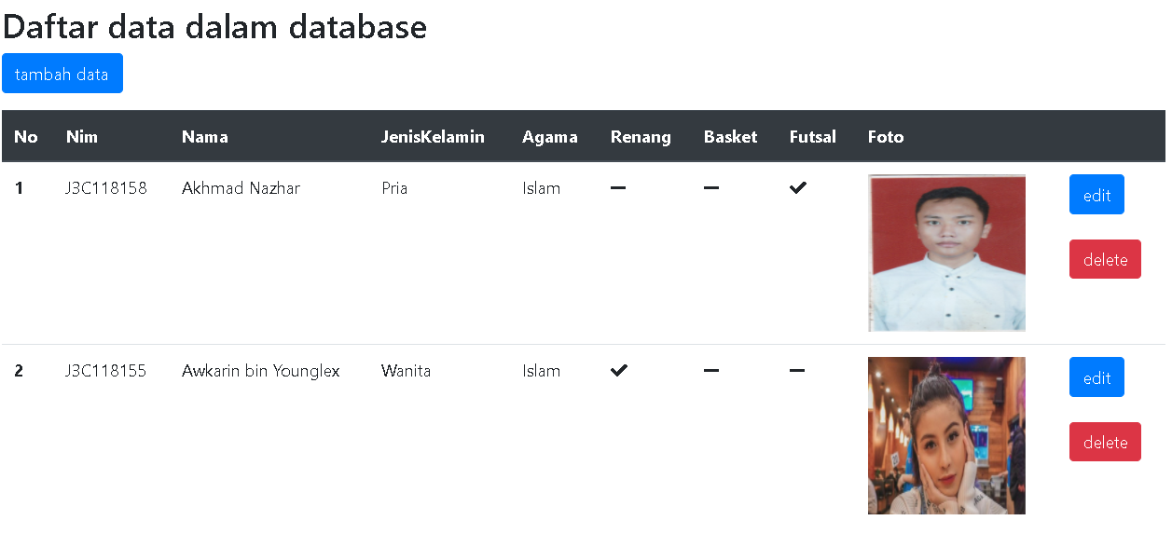

* 1. Menghapus Data  
     

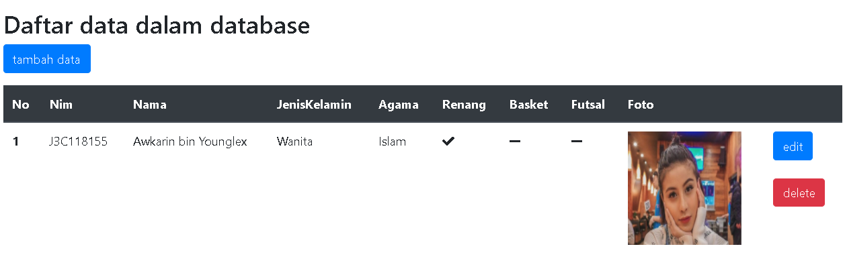

1. Code
   1. Koneksi.php

<?php

$host = "localhost";

$user = "root";

$psw = "";

$db_name= "pabw";

$kon = mysqli_connect($host,$user,$psw,$db_name);

?>

* 1. Tampil_data.php

<!DOCTYPE html>

<html>

<head>

<link rel="stylesheet" href="https://use.fontawesome.com/releases/v5.7.0/css/all.css" integrity="sha384-lZN37f5QGtY3VHgisS14W3ExzMWZxybE1SJSEsQp9S+oqd12jhcu+A56Ebc1zFSJ" crossorigin="anonymous">

<!-- Required meta tags -->

<meta charset="utf-8">

<meta name="viewport" content="width=device-width, initial-scale=1, shrink-to-fit=no">

<!-- Bootstrap CSS -->

<link rel="stylesheet" href="https://stackpath.bootstrapcdn.com/bootstrap/4.5.2/css/bootstrap.min.css" integrity="sha384-JcKb8q3iqJ61gNV9KGb8thSsNjpSL0n8PARn9HuZOnIxN0hoP+VmmDGMN5t9UJ0Z" crossorigin="anonymous">

<title></title>

</head>

<body>

<div class='container mt-3'>

<h2>Daftar data dalam database</h2>

<a href="insert.php" class="btn btn-primary">tambah data</a>

<table class="table mt-3">

<thead class="thead-dark">

<tr>

<th scope="col">No</th>

<th scope="col">Nim</th>

<th scope="col">Nama</th>

<th scope="col">JenisKelamin</th>

<th scope="col">Agama</th>

<th scope="col">Renang</th>

<th scope="col">Basket</th>

<th scope="col">Futsal</th>

<th scope="col">Foto</th>

<th scope="col"></th>

</tr>

</thead>

<tbody>

<?php

include "koneksi.php";

$r = mysqli_query($kon,"SELECT * FROM mahasiswa");

$i = 0;

while($brs = mysqli_fetch_assoc($r)){

if($brs['renang'] == 1)

$hobi1="<span class='fas fa-check'></span>";

else

$hobi1="<span class='fas fa-minus'></span>";

if($brs['basket'] == 1)

$hobi2="<span class='fas fa-check'></span>";

else

$hobi2="<span class='fas fa-minus'></span>";

if($brs['futsal'] == 1)

$hobi3="<span class='fas fa-check'></span>";

else

$hobi3="<span class='fas fa-minus'></span>";

echo '

<tr>

<th scope=row>'.++$i.'</th>

<td>'.$brs['nim'].'</td>

<td>'.$brs['nama'].'</td>

<td>'.$brs['jenisKelamin'].'</td>

<td>'.$brs['agama'].'</td>

<td>'.$hobi1.'</td>

<td>'.$hobi2.'</td>

<td>'.$hobi3.'</td>

<td> <img src="images/'.$brs['foto'].'" width="150" height="150"></td>

<td> <a class="btn btn-primary" href="edit.php?id='.$brs['id'].'">edit</a><br><br> <a class="btn btn-danger" href="delete.php?id='.$brs['id'].'">delete</a><br>

</tr>

';

}

?>

</tbody>

</table>

</div>

<!-- Optional JavaScript -->

<!-- jQuery first, then Popper.js, then Bootstrap JS -->

<script src="https://code.jquery.com/jquery-3.5.1.slim.min.js" integrity="sha384-DfXdz2htPH0lsSSs5nCTpuj/zy4C+OGpamoFVy38MVBnE+IbbVYUew+OrCXaRkfj" crossorigin="anonymous"></script>

<script src="https://cdn.jsdelivr.net/npm/popper.js@1.16.1/dist/umd/popper.min.js" integrity="sha384-9/reFTGAW83EW2RDu2S0VKaIzap3H66lZH81PoYlFhbGU+6BZp6G7niu735Sk7lN" crossorigin="anonymous"></script>

<script src="https://stackpath.bootstrapcdn.com/bootstrap/4.5.2/js/bootstrap.min.js" integrity="sha384-B4gt1jrGC7Jh4AgTPSdUtOBvfO8shuf57BaghqFfPlYxofvL8/KUEfYiJOMMV+rV" crossorigin="anonymous"></script>

</body>

</html>

* 1. Insert.php

<!DOCTYPE html>

<html>

<head>

<!-- Required meta tags -->

<meta charset="utf-8">

<meta name="viewport" content="width=device-width, initial-scale=1, shrink-to-fit=no">

<!-- Bootstrap CSS -->

<link rel="stylesheet" href="https://stackpath.bootstrapcdn.com/bootstrap/4.5.2/css/bootstrap.min.css" integrity="sha384-JcKb8q3iqJ61gNV9KGb8thSsNjpSL0n8PARn9HuZOnIxN0hoP+VmmDGMN5t9UJ0Z" crossorigin="anonymous">

<title></title>

</head>

<body>

<div class="container mt-3">

<h2>Form tambah data baru</h2>

<form method ="POST" enctype="multipart/form-data">

<div class="form-group">

<label for="nim">Nim</label>

<input type="text" class="form-control" id="nim" name="nim" placeholder="Masukkan nim">

</div>

<div class="form-group">

<label for="nama">Nama</label>

<input type="text" class="form-control" id="nama" name="nama" placeholder="Masukkan nama">

</div>

<div class="form-group">

<label for="jenisKelamin">Jenis Kelamin</label>

<br><input type="radio" name="jenisKelamin" value="Pria">Pria<br>

<input type="radio" name="jenisKelamin" value="Wanita">Wanita<br>

</div>

<div class="form-group">

<label for="agama">Agama</label><br>

<select name="agama" id="agama">

<option value="Islam">Islam</option>

<option value="Kristen">Kristen</option>

<option value="Hindu">Hindu</option>

<option value="Budha">Budha</option>

<option value="Konghucu">Konghucu</option>

<option value="Atheis">Atheis</option>

</select><br>

</div>

<div class="form-group">

<label for="olahraga">Olahraga Favorit</label>

<br>

<input type='hidden' name='renang' value=0>

<input type='hidden' name='basket' value=0>

<input type='hidden' name='futsal' value=0>

<input type="checkbox" id="renang" name="renang" value=1>

<label for="renang"> Berenang</label><br>

<input type="checkbox" id="basket" name="basket" value=1>

<label for="basket"> Basket</label><br>

<input type="checkbox" id="futsal" name="futsal" value=1>

<label for="futsal"> Futsal</label><br>

</div>

<div class="form-group">

<label for="foto">Foto Mahasiswa</label><br>

<input type="file" name="foto">

</div>

<input type="submit" class="btn btn-primary" name="sub" value="Kembali">

<input type="submit" class="btn btn-primary" name="sub" value="Simpan">

<?php

if(isset($_POST['sub'])){

if($_POST['sub']=='Kembali'){

header("location:tampil_data.php");

}

else{

if(strlen($_POST['nama'])){

include "koneksi.php";

$target = "images/".basename($_FILES['foto']['name']);

$img = $_FILES['foto']['name'];

$perintah = "INSERT INTO mahasiswa (nim,nama,jenisKelamin,agama,renang,basket,futsal,foto)

VALUES ('".$_POST['nim'].

"','".$_POST['nama'].

"','".$_POST['jenisKelamin'].

"','".$_POST['agama'].

"',".$_POST['renang'].

",".$_POST['basket'].

",".$_POST['futsal'].

",'".$img."')";

if(!move_uploaded_file($_FILES['foto']['tmp_name'], $target)) {

echo 'Your file was not uploaded please try again

here are your debug informations:

'.print_r($_FILES);

}

mysqli_query($kon,$perintah) or die(mysqli_error($kon));

echo "<br>Data <b>'".$_POST['nama']."'</b> telah dimasukan ke database";

echo "<br>silahkan klik tombol kembali ke daftar data untuk melihat hasilnya";

//header("location:tampil_data_link_insert.php");

}

else{

echo "Agar data tersimpan, nama tidak boleh kosong :)";

}

}

}

?>

</form>

</div>

<!-- Optional JavaScript -->

<!-- jQuery first, then Popper.js, then Bootstrap JS -->

<script src="https://code.jquery.com/jquery-3.5.1.slim.min.js" integrity="sha384-DfXdz2htPH0lsSSs5nCTpuj/zy4C+OGpamoFVy38MVBnE+IbbVYUew+OrCXaRkfj" crossorigin="anonymous"></script>

<script src="https://cdn.jsdelivr.net/npm/popper.js@1.16.1/dist/umd/popper.min.js" integrity="sha384-9/reFTGAW83EW2RDu2S0VKaIzap3H66lZH81PoYlFhbGU+6BZp6G7niu735Sk7lN" crossorigin="anonymous"></script>

<script src="https://stackpath.bootstrapcdn.com/bootstrap/4.5.2/js/bootstrap.min.js" integrity="sha384-B4gt1jrGC7Jh4AgTPSdUtOBvfO8shuf57BaghqFfPlYxofvL8/KUEfYiJOMMV+rV" crossorigin="anonymous"></script>

</body>

</html>

* 1. Edit.php

<!DOCTYPE html>

<html>

<head>

<!-- Required meta tags -->

<meta charset="utf-8">

<meta name="viewport" content="width=device-width, initial-scale=1, shrink-to-fit=no">

<!-- Bootstrap CSS -->

<link rel="stylesheet" href="https://stackpath.bootstrapcdn.com/bootstrap/4.5.2/css/bootstrap.min.css" integrity="sha384-JcKb8q3iqJ61gNV9KGb8thSsNjpSL0n8PARn9HuZOnIxN0hoP+VmmDGMN5t9UJ0Z" crossorigin="anonymous">

<title></title>

</head>

<body>

<div class="container mt-3">

<h2>Form edit data</h2>

<form method="POST" enctype="multipart/form-data">

<?php

include "koneksi.php";

if(isset($_POST['sub']))

$x = $_POST['idnya'];

else

$x = $_GET['id'];

?>

<div class="form-group">

<label for="nim">Nim</label>

<input type="text" class="form-control" name="nim" value="<?php

if(isset($_POST['sub']))

echo $_POST['nim'];

else{

$r = mysqli_query($kon,"SELECT * FROM mahasiswa WHERE id=$x");

$brs = mysqli_fetch_assoc($r);

echo $brs['nim'];

}

?>">

</div>

<div class="form-group">

<label for="nama">Nama</label>

<input type="text" class="form-control" name="nama" value="<?php

if(isset($_POST['sub']))

echo $_POST['nama'];

else{

$r = mysqli_query($kon,"SELECT * FROM mahasiswa WHERE id=$x");

$brs = mysqli_fetch_assoc($r);

echo $brs['nama'];

}

?>">

</div>

<div class="form-group">

<label for="jenisKelamin">Jenis Kelamin</label>

<br><input type="radio" name="jenisKelamin" value="Pria"

<?php

if(isset($_POST['sub'])){

if($_POST['jenisKelamin'] == "Pria"){

echo "checked";

}

}

else{

$r = mysqli_query($kon,"SELECT * FROM mahasiswa WHERE id=$x");

$brs = mysqli_fetch_assoc($r);

if($brs['jenisKelamin'] == "Pria"){

echo "checked";

};

}

?>

>Pria<br>

<input type="radio" name="jenisKelamin" value="Wanita"

<?php

if(isset($_POST['sub'])){

if($_POST['jenisKelamin'] == "Wanita"){

echo "checked";

}

}

else{

$r = mysqli_query($kon,"SELECT * FROM mahasiswa WHERE id=$x");

$brs = mysqli_fetch_assoc($r);

if($brs['jenisKelamin'] == "Wanita"){

echo "checked";

};

}

?>

>Wanita<br>

</div>

<div class="form-group">

<label for="agama">Agama</label><br>

<select name="agama" id="agama">

<option value="Islam"

<?php

if(isset($_POST['sub'])){

if($_POST['agama'] == "Islam")

echo "selected";

}

else{

$r = mysqli_query($kon,"SELECT * FROM mahasiswa WHERE id=$x");

$brs = mysqli_fetch_assoc($r);

if($brs['agama'] == "Islam"){

echo "selected";

}

}

?>

>Islam</option>

<option value="Kristen"

<?php

if(isset($_POST['sub'])){

if($_POST['agama'] == "Kristen")

echo "selected";

}

else{

$r = mysqli_query($kon,"SELECT * FROM mahasiswa WHERE id=$x");

$brs = mysqli_fetch_assoc($r);

if($brs['agama'] == "Kristen"){

echo "selected";

}

}

?>

>Kristen</option>

<option value="Hindu"

<?php

if(isset($_POST['sub'])){

if($_POST['agama'] == "Hindu")

echo "selected";

}

else{

$r = mysqli_query($kon,"SELECT * FROM mahasiswa WHERE id=$x");

$brs = mysqli_fetch_assoc($r);

if($brs['agama'] == "Hindu"){

echo "selected";

}

}

?>

>Hindu</option>

<option value="Budha"

<?php

if(isset($_POST['sub'])){

if($_POST['agama'] == "Budha")

echo "selected";

}

else{

$r = mysqli_query($kon,"SELECT * FROM mahasiswa WHERE id=$x");

$brs = mysqli_fetch_assoc($r);

if($brs['agama'] == "Budha"){

echo "selected";

}

}

?>

>Budha</option>

<option value="Konghucu"

<?php

if(isset($_POST['sub'])){

if($_POST['agama'] == "Konghucu")

echo "selected";

}

else{

$r = mysqli_query($kon,"SELECT * FROM mahasiswa WHERE id=$x");

$brs = mysqli_fetch_assoc($r);

if($brs['agama'] == "Konghucu"){

echo "selected";

}

}

?>

>Konghucu</option>

<option value="Atheis"

<?php

if(isset($_POST['sub'])){

if($_POST['agama'] == "Atheis")

echo "selected";

}

else{

$r = mysqli_query($kon,"SELECT * FROM mahasiswa WHERE id=$x");

$brs = mysqli_fetch_assoc($r);

if($brs['agama'] == "Atheis"){

echo "selected";

}

}

?>

>Atheis</option>

</select><br>

</div>

<div class="form-group">

<label for="olahraga">Olahraga Favorit </label>

<br>

<input type='hidden' name='renang' value=0>

<input type='hidden' name='basket' value=0>

<input type='hidden' name='futsal' value=0>

<input type="checkbox" id="renang" name="renang" value=1

<?php

if(isset($_POST['sub'])){

if($_POST['renang'] == 1){

echo "checked";

}

}

else{

$r = mysqli_query($kon,"SELECT * FROM mahasiswa WHERE id=$x");

$brs = mysqli_fetch_assoc($r);

if($brs['renang'] == 1){

echo "checked";

};

}

?>

>

<label for="renang"> Berenang</label><br>

<input type="checkbox" id="basket" name="basket" value=1

<?php

if(isset($_POST['sub'])){

if($_POST['basket'] == 1){

echo "checked";

}

}

else{

$r = mysqli_query($kon,"SELECT * FROM mahasiswa WHERE id=$x");

$brs = mysqli_fetch_assoc($r);

if($brs['basket'] == 1){

echo "checked";

};

}

?>

>

<label for="basket"> Basket</label><br>

<input type="checkbox" id="futsal" name="futsal" value=1

<?php

if(isset($_POST['sub'])){

if($_POST['futsal'] == 1){

echo "checked";

}

}

else{

$r = mysqli_query($kon,"SELECT * FROM mahasiswa WHERE id=$x");

$brs = mysqli_fetch_assoc($r);

if($brs['futsal'] == 1){

echo "checked";

};

}

?>

>

<label for="futsal"> Futsal</label><br>

</div>

<div class="form-group">

<label for="foto">Foto</label><br>

<?php

if(isset($_POST['sub'])){

$r = mysqli_query($kon,"SELECT foto FROM mahasiswa WHERE id=$x");

$foto=mysqli_fetch_assoc($r)['foto'];

echo "<img src='images/$foto' width='150' height='150'";

}else{

$r = mysqli_query($kon,"SELECT foto FROM mahasiswa WHERE id=$x");

$foto=mysqli_fetch_assoc($r)['foto'];

echo "<img src='images/$foto' width='150' height='150'";

}

?>

<br>

<input type="file" name="foto">

</div>

<input type="submit" class="btn btn-primary" name="sub" value="kembali ke daftar data">

<input type="submit" class="btn btn-primary" name="sub" value="simpan hasil pengubahan!">

<input type="hidden" name="idnya" value="<?php echo $x; ?>">

<?php

if(isset($_POST['sub']) ){

if($_POST['sub']=='kembali ke daftar data'){

header("location:tampil_data.php");

}

else{

if(strlen($_POST['nama'])){

//include "koneksi.php"; //di atas sudah ya

$target = "images/".basename($_FILES['foto']['name']);

$img = $_FILES['foto']['name'];

if(!move_uploaded_file($_FILES['foto']['tmp_name'], $target)) {

echo 'Your file was not uploaded please try again

here are your debug informations:

'.print_r($_FILES);

}else{

$r = mysqli_query($kon,"SELECT foto FROM mahasiswa WHERE id=$x");

$foto=mysqli_fetch_assoc($r)['foto'];

unlink("images/".$foto);

}

$kueri="UPDATE `mahasiswa` SET `nama` = '".$_POST['nama']."',

`nim` = '".$_POST['nim']."',

`jenisKelamin` = '".$_POST['jenisKelamin']."',

`agama` = '".$_POST['agama']."',

`renang` = '".$_POST['renang']."',

`basket` = '".$_POST['basket']."',

`futsal` = '".$_POST['futsal']."',

`foto` = '".$img."'

WHERE `id` = ".$_POST['idnya'];

mysqli_query($kon,$kueri);

echo "<br>Data <b>'".$_POST['nama']."'</b> telah disimpan sebagai perubahan pada database";

echo "<br>silahkan klik tombol kembali ke daftar data untuk melihat hasilnya";

//header("location:tampil_data_link_insert.php");

}

else{

echo "Data nama baru tidak boleh kosong :)";

}

}

}

?>

</form>

</div>

</body>

<!-- Optional JavaScript -->

<!-- jQuery first, then Popper.js, then Bootstrap JS -->

<script src="https://code.jquery.com/jquery-3.5.1.slim.min.js" integrity="sha384-DfXdz2htPH0lsSSs5nCTpuj/zy4C+OGpamoFVy38MVBnE+IbbVYUew+OrCXaRkfj" crossorigin="anonymous"></script>

<script src="https://cdn.jsdelivr.net/npm/popper.js@1.16.1/dist/umd/popper.min.js" integrity="sha384-9/reFTGAW83EW2RDu2S0VKaIzap3H66lZH81PoYlFhbGU+6BZp6G7niu735Sk7lN" crossorigin="anonymous"></script>

<script src="https://stackpath.bootstrapcdn.com/bootstrap/4.5.2/js/bootstrap.min.js" integrity="sha384-B4gt1jrGC7Jh4AgTPSdUtOBvfO8shuf57BaghqFfPlYxofvL8/KUEfYiJOMMV+rV" crossorigin="anonymous"></script>

</html>

* 1. Delete.php

<!DOCTYPE html>

<html>

<head>

<!-- Required meta tags -->

<meta charset="utf-8">

<meta name="viewport" content="width=device-width, initial-scale=1, shrink-to-fit=no">

<!-- Bootstrap CSS -->

<link rel="stylesheet" href="https://stackpath.bootstrapcdn.com/bootstrap/4.5.2/css/bootstrap.min.css" integrity="sha384-JcKb8q3iqJ61gNV9KGb8thSsNjpSL0n8PARn9HuZOnIxN0hoP+VmmDGMN5t9UJ0Z" crossorigin="anonymous">

<title></title>

</head>

<body>

<form>

<?php

include "koneksi.php";

$r = mysqli_query($kon,"SELECT * FROM mahasiswa WHERE id=".$_GET["id"]);

$brs = mysqli_fetch_assoc($r);

echo "apakah Anda yakin akan menghapus nama ".$brs['nama']." dari tabel?";

?>

<input type="hidden" name="idDelete" value="<?php echo $_GET["id"]; ?>">

<input type="submit" name="jawaban" value="ya">

<input type="submit" name="jawaban" value="tidak">

</form>

<?php

if(isset($_GET['jawaban'])){

if($_GET['jawaban']=="tidak")

header("location:tampil_data.php");

else{

$r = mysqli_query($kon,"DELETE FROM `mahasiswa` WHERE `id` = ".$_GET['idDelete']);

header("location:tampil_data.php");

}

}

?>

<!-- Optional JavaScript -->

<!-- jQuery first, then Popper.js, then Bootstrap JS -->

<script src="https://code.jquery.com/jquery-3.5.1.slim.min.js" integrity="sha384-DfXdz2htPH0lsSSs5nCTpuj/zy4C+OGpamoFVy38MVBnE+IbbVYUew+OrCXaRkfj" crossorigin="anonymous"></script>

<script src="https://cdn.jsdelivr.net/npm/popper.js@1.16.1/dist/umd/popper.min.js" integrity="sha384-9/reFTGAW83EW2RDu2S0VKaIzap3H66lZH81PoYlFhbGU+6BZp6G7niu735Sk7lN" crossorigin="anonymous"></script>

<script src="https://stackpath.bootstrapcdn.com/bootstrap/4.5.2/js/bootstrap.min.js" integrity="sha384-B4gt1jrGC7Jh4AgTPSdUtOBvfO8shuf57BaghqFfPlYxofvL8/KUEfYiJOMMV+rV" crossorigin="anonymous"></script>

</body>

</html>

* 1. MySQL

-- phpMyAdmin SQL Dump

-- version 4.9.0.1

-- https://www.phpmyadmin.net/

--

-- Host: 127.0.0.1

-- Generation Time: Sep 26, 2020 at 04:18 PM

-- Server version: 10.4.6-MariaDB

-- PHP Version: 7.3.8

SET SQL_MODE = "NO_AUTO_VALUE_ON_ZERO";

SET AUTOCOMMIT = 0;

START TRANSACTION;

SET time_zone = "+00:00";

/*!40101 SET @OLD_CHARACTER_SET_CLIENT=@@CHARACTER_SET_CLIENT */;

/*!40101 SET @OLD_CHARACTER_SET_RESULTS=@@CHARACTER_SET_RESULTS */;

/*!40101 SET @OLD_COLLATION_CONNECTION=@@COLLATION_CONNECTION */;

/*!40101 SET NAMES utf8mb4 */;

--

-- Database: `pabw`

--

-- --------------------------------------------------------

--

-- Table structure for table `mahasiswa`

--

CREATE TABLE `mahasiswa` (

`id` int(11) NOT NULL,

`nim` varchar(9) NOT NULL,

`nama` varchar(30) NOT NULL,

`jenisKelamin` varchar(6) NOT NULL,

`agama` varchar(10) NOT NULL,

`renang` int(1) DEFAULT NULL,

`basket` int(1) DEFAULT NULL,

`futsal` int(1) DEFAULT NULL,

`foto` varchar(200) NOT NULL

) ENGINE=InnoDB DEFAULT CHARSET=latin1;

--

-- Dumping data for table `mahasiswa`

--

INSERT INTO `mahasiswa` (`id`, `nim`, `nama`, `jenisKelamin`, `agama`, `renang`, `basket`, `futsal`, `foto`) VALUES

(40, 'J3C118155', 'Awkarin bin Younglex', 'Wanita', 'Islam', 1, 0, 0, 'awk.jpg');

--

-- Indexes for dumped tables

--

--

-- Indexes for table `mahasiswa`

--

ALTER TABLE `mahasiswa`

ADD PRIMARY KEY (`id`),

ADD UNIQUE KEY `nim` (`nim`);

--

-- AUTO_INCREMENT for dumped tables

--

--

-- AUTO_INCREMENT for table `mahasiswa`

--

ALTER TABLE `mahasiswa`

MODIFY `id` int(11) NOT NULL AUTO_INCREMENT, AUTO_INCREMENT=41;

COMMIT;

/*!40101 SET CHARACTER_SET_CLIENT=@OLD_CHARACTER_SET_CLIENT */;

/*!40101 SET CHARACTER_SET_RESULTS=@OLD_CHARACTER_SET_RESULTS */;

/*!40101 SET COLLATION_CONNECTION=@OLD_COLLATION_CONNECTION */;